Implementation Readiness Action Plan
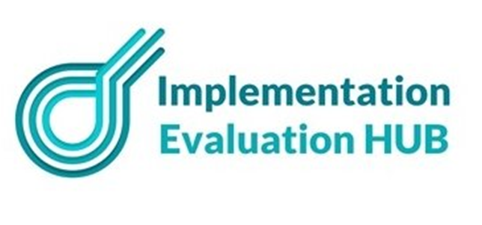

IMPLEMENTATION READINESS ACTION PLAN

Developing an Action Plan Post-Readiness Assessment
After completing an implementation readiness assessment, the next step is to develop a detailed action plan. This plan should address any gaps (Ares with a score of 3 or less) identified and leverage strengths for successful implementation.
Key components include:
- Goal or Objective: Define a clear, specific goal aligned with assessment findings.
- Tasks or Actions: Break down the goal into specific, actionable tasks.
- Timeline: Develop a realistic timeline for each task and the overall goal.
- Resources: Identify necessary resources, including personnel, materials, and equipment.
- Responsibility: Assign each task to a specific person or team.
- Desired Outcomes: Establish KPIs to measure progress and success.
This approach ensures the action plan is tailored to the organisation’s current readiness, facilitating effective implementation.

THE IMPLEMENTATION AND EVALUATION FRAMEWORK
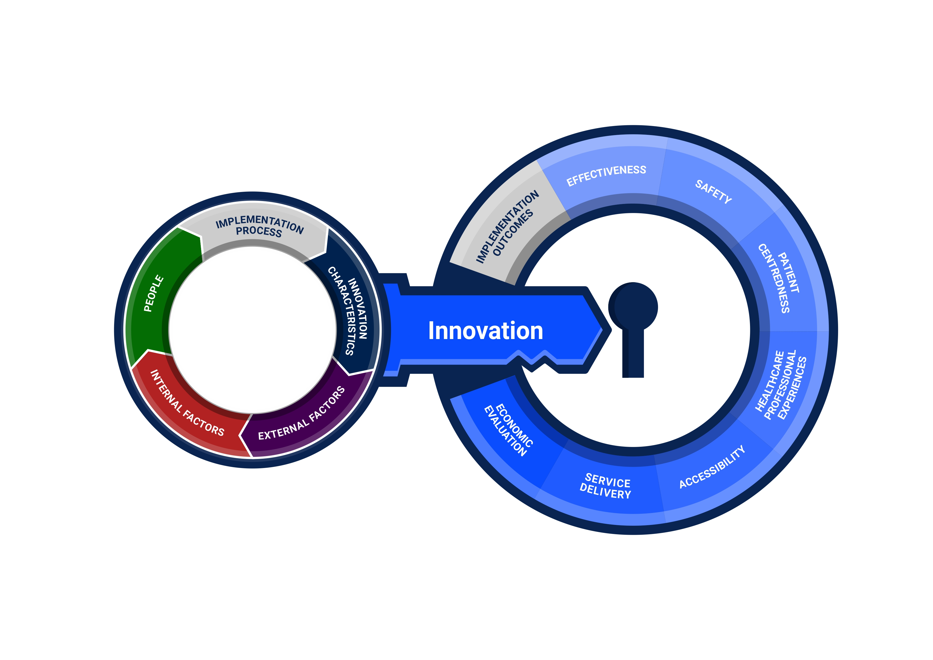

PROJECT NAME
NAME
PROJECT MANAGER | TODAY'S DATE
Name | MM/DD/YY

INNOVATION CHARACTERISTICS
Areas for improvement (These are areas that you had a score between 1-3 in the Implementation Readiness Assessment Tool)

Implementation readiness goal/s (Write objectives that will increase implementation capability in this domain. The objective should be Specific, Measurable, Attainable, Realistic and Timebound)

ACTION DESCRIPTION | RESPONSIBLE | PRIORITY | STATUS | START | END | RESOURCES REQUIRED | DESIRED OUTCOME | NOTES
Action description | Name | (Low, Medium, High) | In progress, Complete, On hold) | MM/DD | MM/DD
Description
EXTERNAL FACTORS
Areas for improvement (These are areas that you had a score between 1-3 in the Implementation Readiness Assessment Tool)

Implementation readiness goal/s (Write objectives that will increase implementation capability in this domain. The objective should be Specific, Measurable, Attainable, Realistic and Timebound)

ACTION DESCRIPTION | RESPONSIBLE | PRIORITY | STATUS | START | END | RESOURCES REQUIRED | DESIRED OUTCOME | NOTES
Action description | Name | (Low, Medium, High) | In progress, Complete, On hold) | MM/DD | MM/DD
Description

INTERNAL FACTORS
Areas for improvement (These are areas that you had a score between 1-3 in the Implementation Readiness Assessment Tool)

Implementation readiness goal/s (Write objectives that will increase implementation capability in this domain. The objective should be Specific, Measurable, Attainable, Realistic and Timebound)

ACTION DESCRIPTION | RESPONSIBLE | PRIORITY | STATUS | START | END | RESOURCES REQUIRED | DESIRED OUTCOME | NOTES
Action description | Name | (Low, Medium, High) | In progress, Complete, On hold) | MM/DD | MM/DD
Description
INTERNAL FACTORS
Areas for improvement (These are areas that you had a score between 1-3 in the Organisational Implementation Readiness Assessment Tool)

Implementation readiness goal/s (Write objectives that will increase implementation capability in this domain. The objective should be Specific, Measurable, Attainable, Realistic and Timebound)

ACTION DESCRIPTION | RESPONSIBLE | PRIORITY | STATUS | START | END | RESOURCES REQUIRED | DESIRED OUTCOME | NOTES
Action description | Name | (Low, Medium, High) | In progress, Complete, On hold) | MM/DD | MM/DD
Description

PEOPLE
Areas for improvement (These are areas that you had a score between 1-3 in the Organisational Implementation Readiness Assessment Tool)

Implementation readiness goal/s (Write objectives that will increase implementation capability in this domain. The objective should be Specific, Measurable, Attainable, Realistic and Timebound)

ACTION DESCRIPTION | RESPONSIBLE | PRIORITY (drop down) | STATUS  (drop down) | START | END | RESOURCES REQUIRED | DESIRED OUTCOME | NOTES
Action description | Name | (Low, Medium, High) | In progress, Complete, On hold) | MM/DD | MM/DD
Description

IMPLEMENTATION PROCESS
Areas for improvement (These are areas that you had a score between 1-3 in the Organisational Implementation Readiness Assessment Tool)

Implementation readiness goal/s (Write objectives that will increase implementation capability in this domain. The objective should be Specific, Measurable, Attainable, Realistic and Timebound)

ACTION DESCRIPTION | RESPONSIBLE | PRIORITY (drop down) | STATUS  (drop down) | START | END | RESOURCES REQUIRED | DESIRED OUTCOME | NOTES
Action description | Name | (Low, Medium, High) | In progress, Complete, On hold) | MM/DD | MM/DD
Description

OUTCOMES AND PERFORMANCE MEASUREMENT
Areas for improvement (These are areas that you had a score between 1-3 in the Organisational Implementation Readiness Assessment Tool)

Implementation readiness goal/s (Write objectives that will increase implementation capability in this domain. The objective should be Specific, Measurable, Attainable, Realistic and Timebound)

ACTION DESCRIPTION | RESPONSIBLE | PRIORITY (drop down) | STATUS  (drop down) | START | END | RESOURCES REQUIRED | DESIRED OUTCOME | NOTES
Action description | Name | (Low, Medium, High) | In progress, Complete, On hold) | MM/DD | MM/DD
Description

